**Bayus Transit Company Limited**

**Bayus Transit System User Manual**  
A Comprehensive Guide to Using the System   
  


2025

# Table of content.

1. Introduction 3

2. User Categories in the Bayusi System 3

3. System Accessibility 3

4. Homepage Layout 4

5. Navigation Menu 4

6. Key Steps for System Usage. 5

6.1. Logging into the System via Login Form 5

6.2. How to Register as a Vehicle Owner 7

6.3. Registering Companies 8

6.4. Vehicle Owner Registration and Company Information 10

6.5. The Customer Places an Order Based on Their Needs 13

6.5.1. Booking a Vehicle 13

6.5.2. Making a Reservation 15

6.6. Afterward, the Vehicle Owner Can Confirm or Reject the Order via Other Communication Methods 18

6.7. Vehicles/trucks hosting payment. 19

6.7.1. Orders 20

6.7.2. All Orders 20

6.7.3. Summary: 22

6.8. Permissions 22

7. Contact and Support 23

# Introduction

The **Bayus Transit system** is a modern platform accessible via **web browsers** and **mobile devices** (Android and iOS). This system has been designed to address a major challenge faced by transportation customers—**lack of accurate and timely information** about transportation services.

Through this system, **customers and transportation businesses** can communicate directly, making it easier to plan and coordinate transportation services efficiently. The system allows customers to easily identify **available vehicles for transport** using their preferred device, whether a **computer, laptop, or mobile phone**.

For transportation company owners, the system simplifies customer acquisition, enhancing business efficiency. Overall, **Bayus Transit** helps the community by reducing the difficulties associated with transporting goods and passengers, providing a **modern solution for the transportation industry**.

# User Categories in the Bayusi System

The **Bayusi system** has three types of users:

1. **Super Admin**
   * This is the primary user of the system with the authority to **register vehicles and transportation companies** that wish to use the platform.
2. **Vehicle Owner**
   * This user manages their fleet, providing details about **vehicle availability, locations, and routes** to facilitate transportation services.
3. **Customer**
   * A user who can search for **available vehicles** for transportation needs.

# 3. System Accessibility

The system is accessible through the official website **<https://bayustransit.com>**, a **web-based platform** supporting four languages: **English, Swahili, French, and Kirundi**.

**Requirements to access the system:**

* A **computer or laptop** to access the website, Supported Browsers: Google Chrome, Mozilla Firefox, Safari, And Microsoft Edge
* A **smartphone** to use the **mobile app**, available for download on **Google Play Store** (Android) and **App Store** (iOS) by search Bayus Transit.

# Homepage Layout

The homepage consists of the following sections:  
- Navigation Menu (Home, About, Services, Cars/Trucks, Our Team, Testimonial, Contact, Sign In)

See the image bellow

-web system

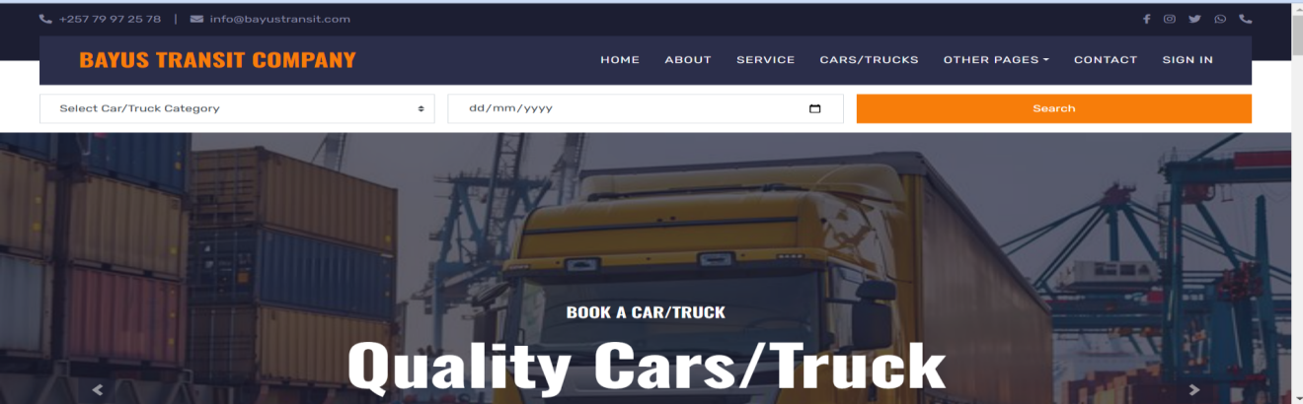

- Other pages in the image contains (Our Team, Testimonial)

-Mobile application

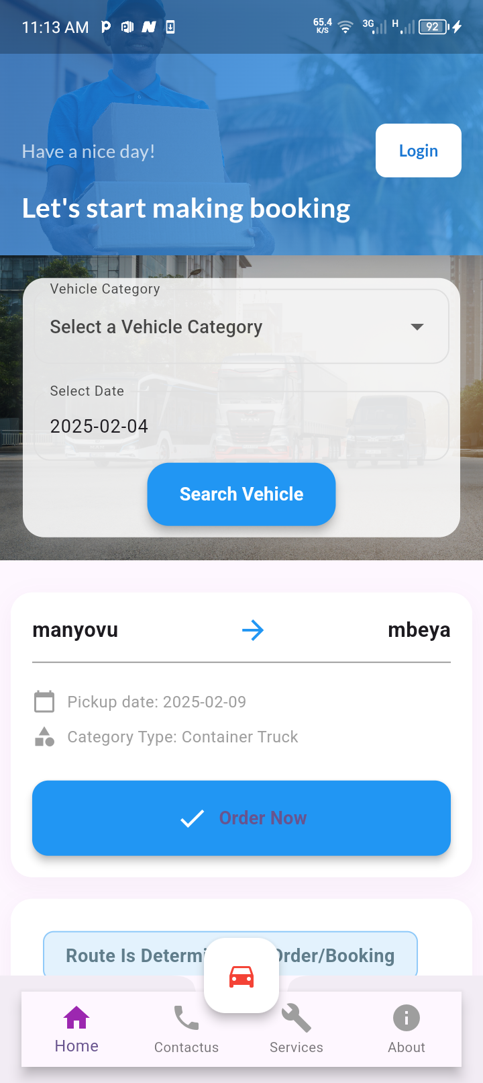

# Navigation Menu

Each menu item provides different functionalities:  
- Home: Returns to the homepage.  
- About: Company history and mission.  
- Services: Details on vehicle hosting and booking.  
- Cars/Trucks: Available vehicles for booking.  
- Our Team: Information about team members.  
- Testimonial: Customer feedback.  
- Contact: Inquiry form and contact details.  
- Sign In: User login access for those who need to host their vehicles only.

# Key Steps for System Usage.

1. **Log in** to the system using the login form.
2. **Register companies** that provide transportation services.
3. **Register an admin or manager** for each company.
4. **Register vehicles** into the system.
5. Once vehicles are registered:
   * **Vehicle owners** can enter details about **available vehicles**, including location and schedule, to receive transportation requests from customers.
   * **Customers** can place orders based on their transportation needs.
   * **Vehicle owners** can **confirm or reject** orders through alternative communication methods such as phone calls.
   * If the order is accepted, both parties will finalize **pickup arrangements**, and payment will be agreed upon between the **customer and the service provider**.

## 6.1. Logging into the System via Login Form

Users of this system will be required to **log into the system** using the **username and password** provided to them for accessing the system.

**User Registration**

* **Transportation Company Owners**: They can register on the system, but they must **wait for approval** from the **Super Admin** before gaining access to system services.
* **Customers**: **Do not need to register** since they will enter their details when placing an **order** for transportation on the system.
* **Super Admin**: **Does not need to register** as they will be **automatically registered** in the system.

Therefore, the only users who can register are the **owners of transportation companies**.

Consider image of login form

-Web system -Mobile application

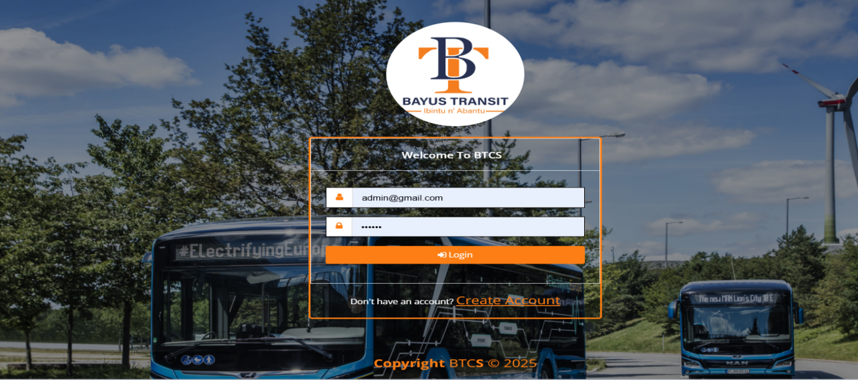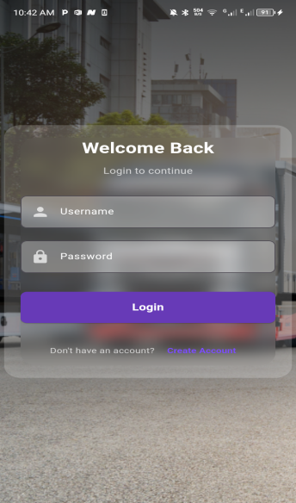

After super admin and other Vehicle Owner login the following dashboard and menu will be seen in the system if the user has permission.

-Web Application

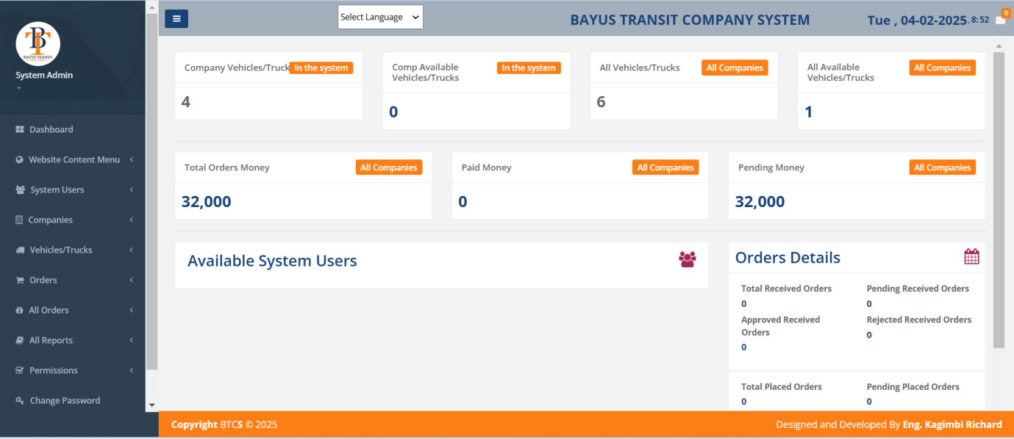

- Mobile application

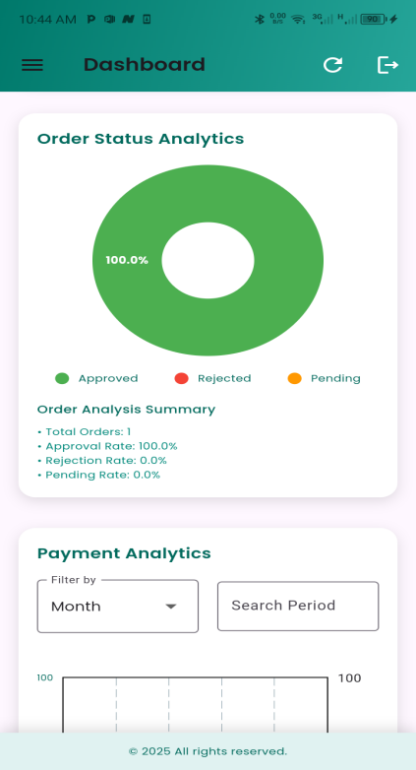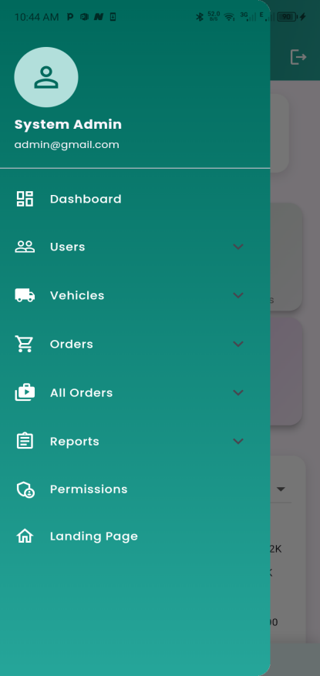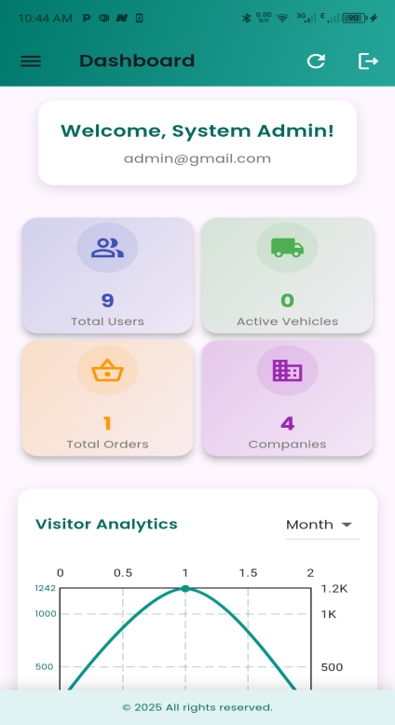

## 6.2. How to Register as a Vehicle Owner

1. **Click "CREATE ACCOUNT"** on a login page shown above.
   * On the login page, find and click **CREATE ACCOUNT**. for both application and web system
2. **Fill Out the Registration Form**
   * A new registration form will open.
   * Enter the following details:
     + **Username**: Choose a unique username.
     + **Full Name**: Enter your full name.
     + **Phone Number**: Provide a valid phone number.
     + **Password**: Create a strong password.
     + **Residence**: Enter your place of residence.

This is done for both web system and mobile application

1. **Save and Complete Registration**
   * After filling in all the details, click **SUBMIT** or **REGISTER** to complete the registration.
   * If successful, you will receive a confirmation message and wait for Approval

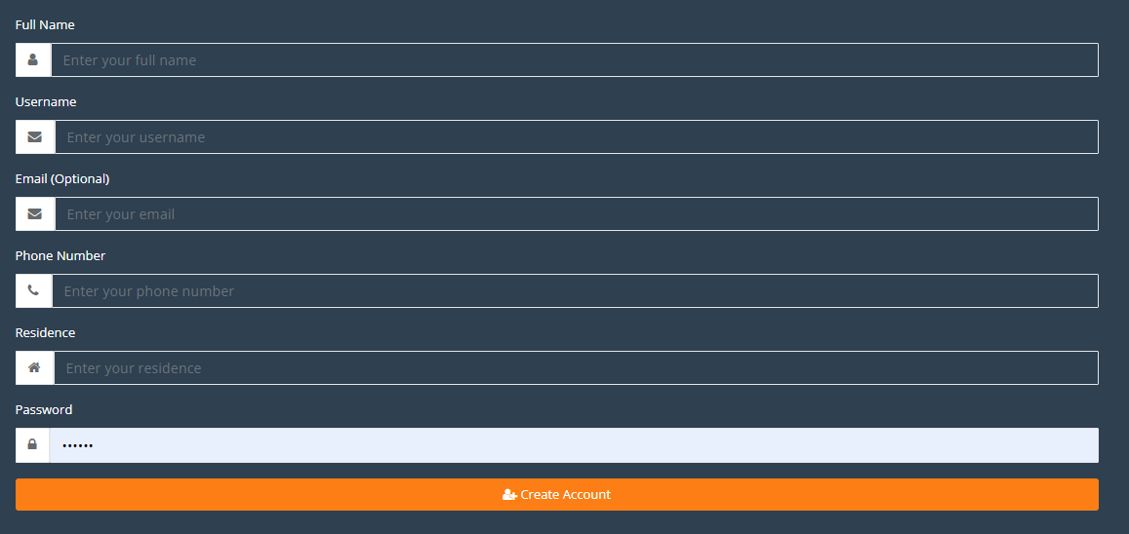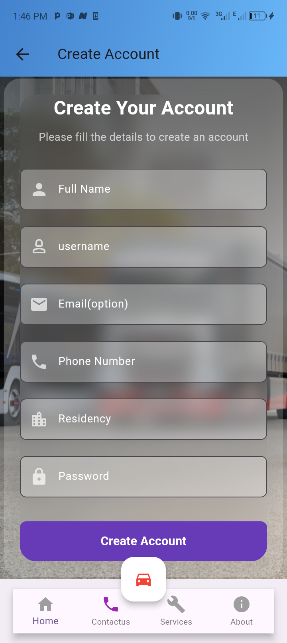

**-Web system -Mobile application**

## 6.3. Registering Companies

Registering transportation companies is the responsibility of the **Super Admin**, or **Transportation Company Owners** once they have successfully registered themselves. A **company owner** can only register their own company.

-For mobile application at the first time Customer login the screen viwed like this.

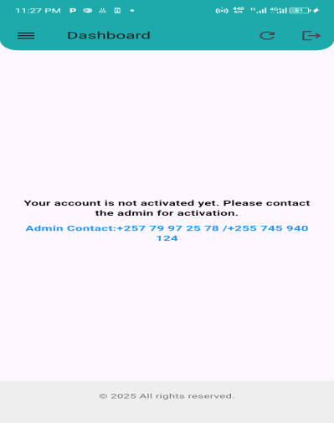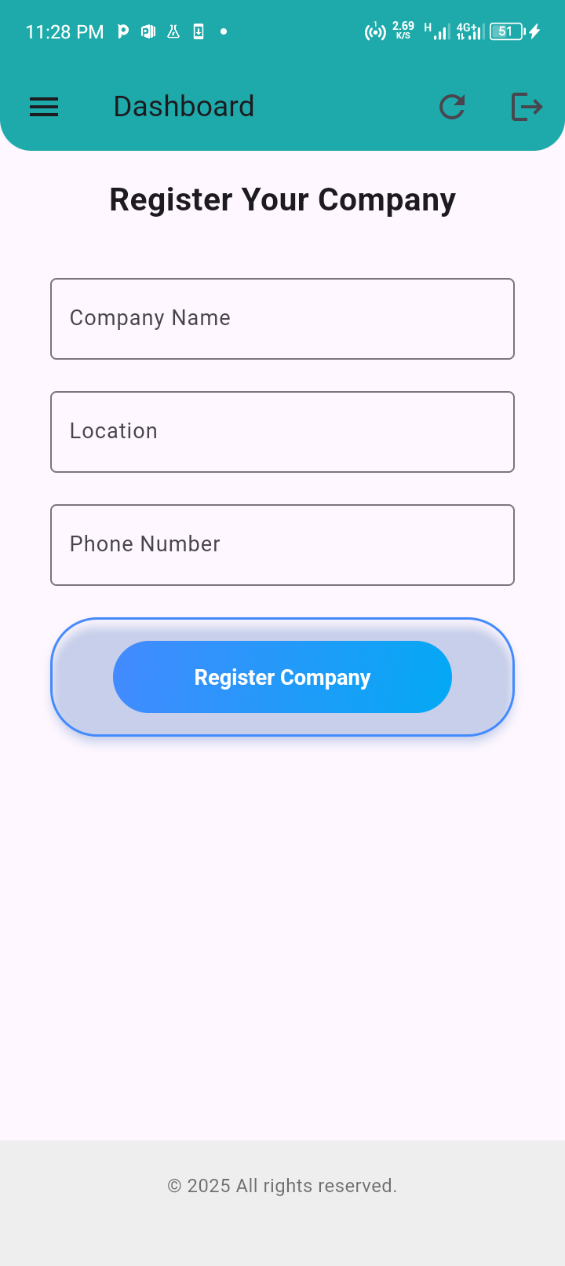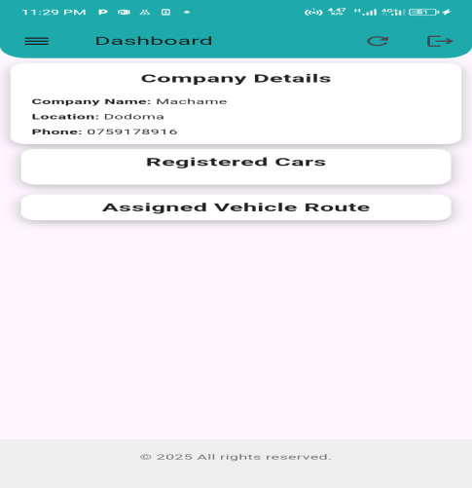

step1 step2 step3

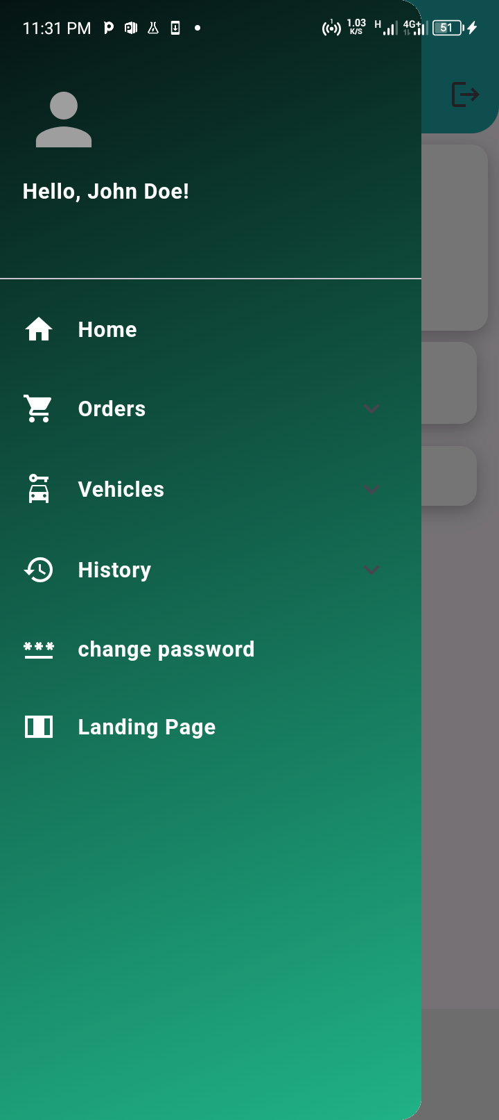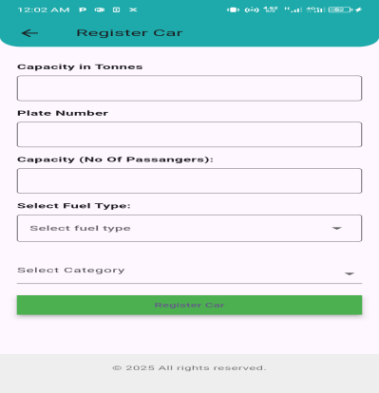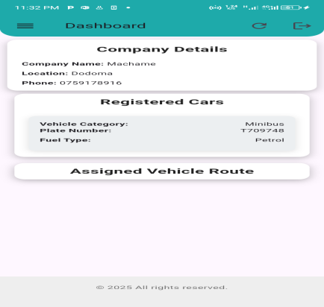

step 4 step 5 step 6

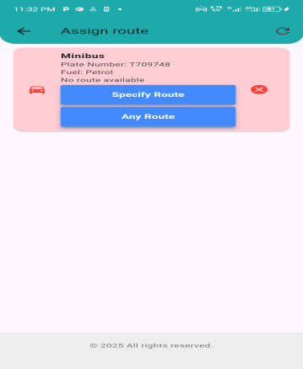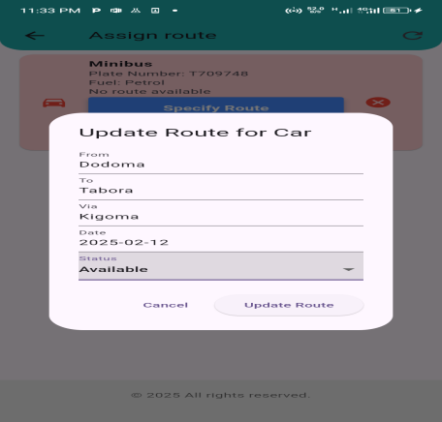

step 7 step 8

**Step 1:**  
When the user logs in for the first time, they will see a message asking them to contact the system administrator to approve their account. After approval, the user should click the refresh icon to register the company information.

**Step 2:**  
After approval, the user is allowed to register the company details. They must refresh the page again to view the changes.

**Step 3:**  
Once the company is registered, the dashboard will now display the company details.

**Step 4:**  
The user will now be able to view the menu for their account.

**Step 5:**  
Under the "Vehicle" section, the user can register vehicle details.

**Step 6:**  
After registering the vehicle, the dashboard will update to show all registered vehicles.

**Step 7:**  
Under the "Vehicle" menu, the user can view all vehicles and has the option to assign a route to a specific vehicle.

**Step 8:**  
Now, the user can assign a route to a vehicle through their account.

The **company information** entered will be displayed in the **order details** once the customer places an order, along with the relevant **vehicle details** for that company.

## 6.4. Vehicle Owner Registration and Company Information

1. **Registration and Approval**
   * After completing the registration, your account will need approval from the system administrator.
   * Once approved, you can log in using your credentials.
2. **Accessing Company Information Form**
   * After logging in, additional menus will remain locked until you provide your company details.
   * To enter your company details:
     + Navigate to **Companies > Register Companies** in the menu.
     + A form will appear where you need to fill in the required company information.

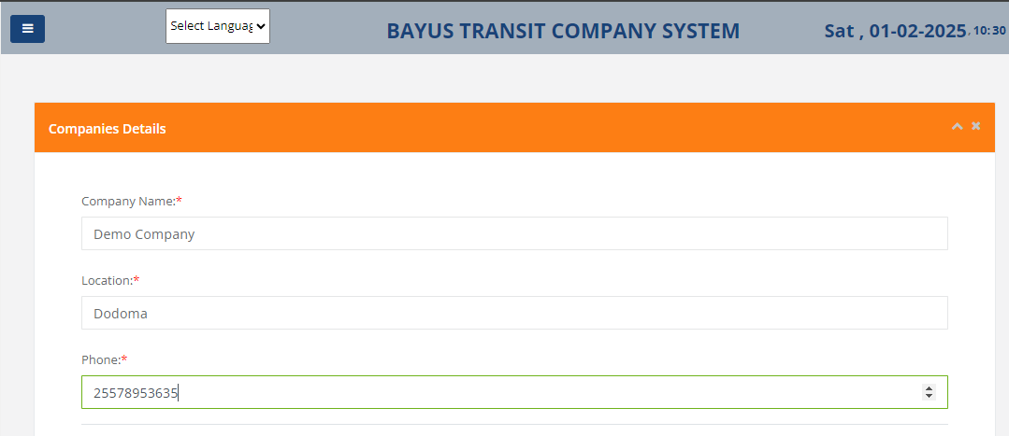

**3. Registering Vehicles**

This step follows all the previous steps outlined. Accurate **vehicle details** must be entered to avoid conflicts or issues during the transportation process. The important details to be provided include **vehicle type, plate number, vehicle name, fuel type**, and other relevant information.

This step can be carried out by either the **vehicle admin** or the **Super Admin**.

Consider Image below

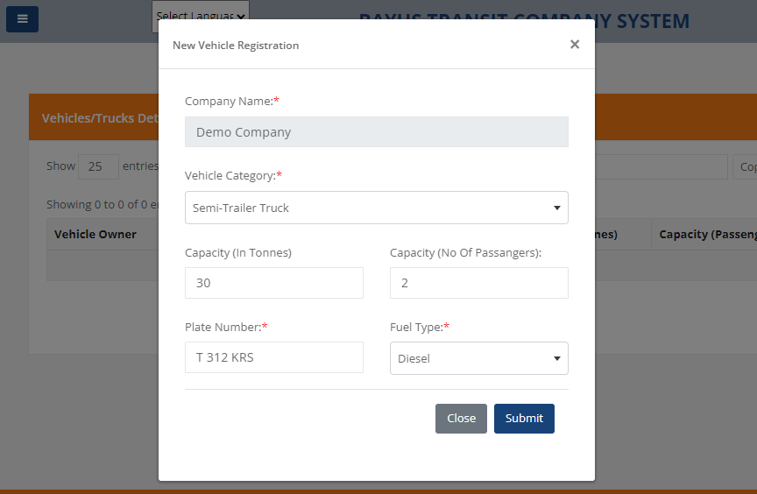

**4. Vehicle Status Registration**

The **vehicle owner** will be able to **register/enter details of the vehicle** that will be available in a specific location to receive transportation orders from various customers.

This is an important step where the **vehicle details and route** will be entered for transportation purposes. The required information includes:

* **Starting point** of the journey
* **Route** the vehicle will take
* **Final destination** of the journey
* **Travel date** for the trip

After completing this step, the vehicle will be added to the list of **vehicles awaiting orders** from customers.

Navigate to **Vehicles/Trucks>Vehicles/Trucks Status** in the menu.

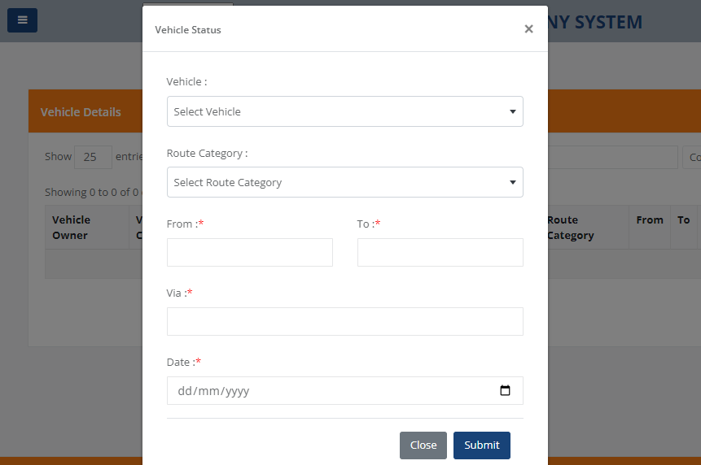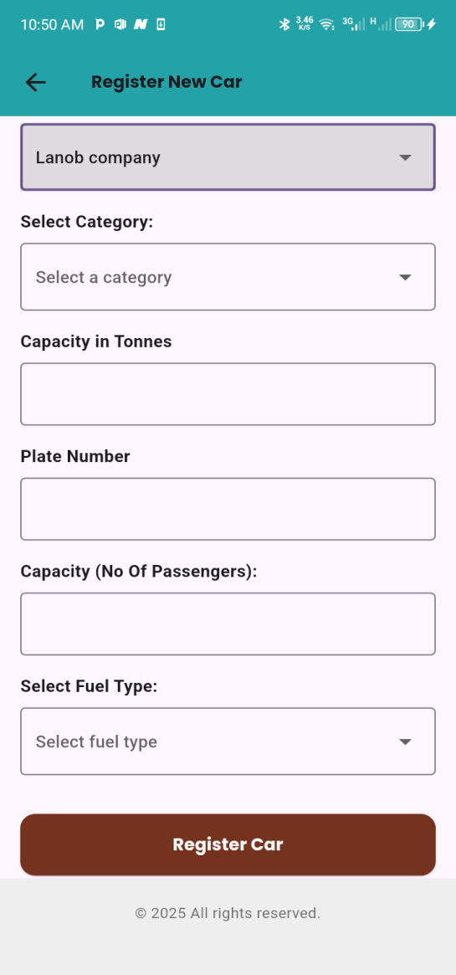

The two categories of route

1. **Specific Route** – This is a well-defined route that specifies:

* The departure location
* The transit points
* The destination
* The specific date of travel

1. **No Route** – This is a flexible route where the vehicle is available on a particular date but does not have a fixed route. It can take any available route.

## 6.5. The Customer Places an Order Based on Their Needs

The customer will be required to go to the **Available Trucks** menu on the website and search using the **Vehicle Type** and **Travel Date**. After that, they will click the **Place Order** button to place an order. Then, they will proceed to enter their details to complete the order.

When the customer wants to **search for available vehicles** for an order, they can select a vehicle based on the **vehicle type** and **date** according to their needs.

Once the customer finds an available vehicle for the journey, they will place an order by entering all the required details, including:

* **Full name**
* **Residential address**
* **Destination address** (where the cargo is to be delivered)
* **Phone number**
* Any other required information

After placing the order, the customer will **wait for approval or rejection** from the **vehicle owner**.

Consider the following steps with images.

### 6.5.1. Booking a Vehicle

Selecting a Vehicle

1. Go to "Cars/Trucks" then select the track u need then click book now.

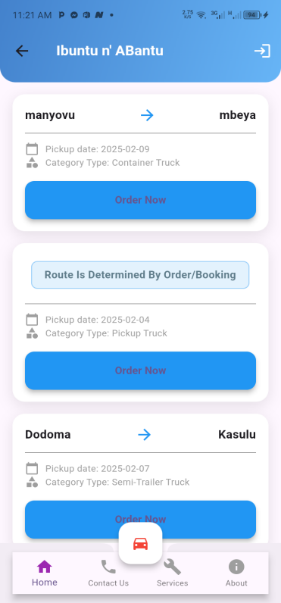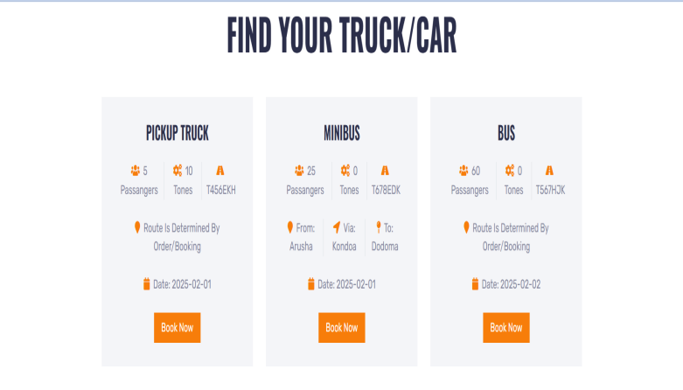

1. Use filters to search select truck category and date then search.

-Web system  
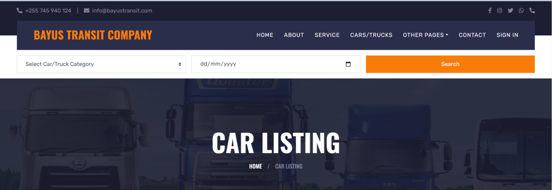

-Mobile application  


### 6.5.2. Making a Reservation

1. Click "Book Now ".  
   2. Fill in the reservation form.

-web system

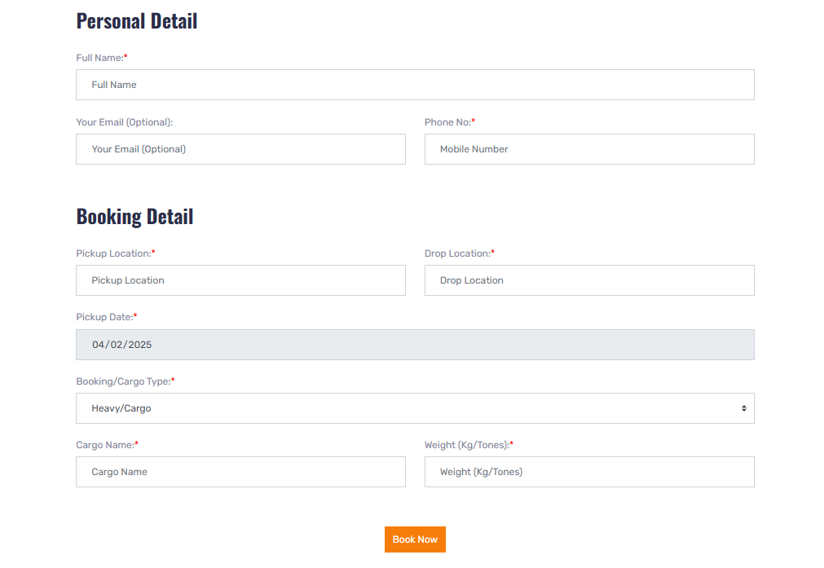

-Mobile application

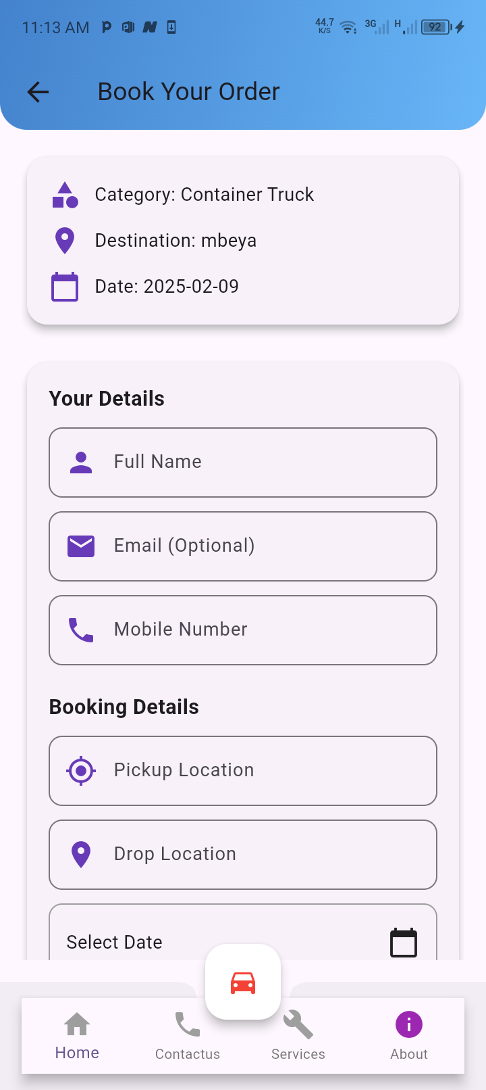

3. Submit the form.

But from the system the owner of the vehicle has access to help his/her customer to book his/her trucks by filling the following form in the system after selecting his/her free trucks based on customer need.

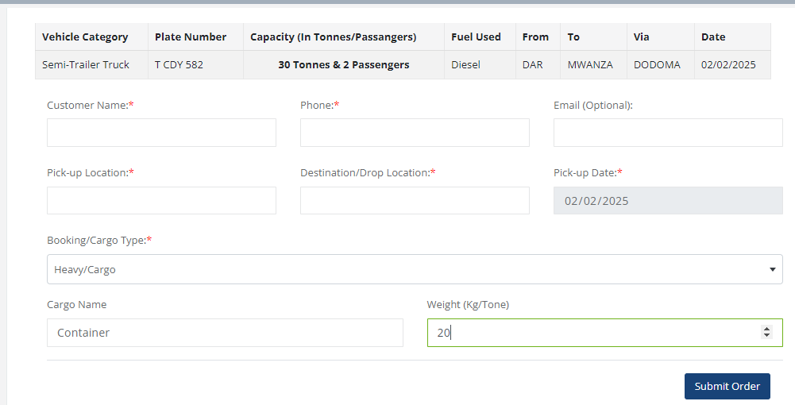

## 6.6. **Afterward, the Vehicle Owner Can Confirm or Reject the Order via Other Communication Methods**

Once the order is placed by the customer, the **vehicle owner** will need to provide feedback to the customer regarding whether the order has been **approved or rejected** for transportation. This is crucial to provide the customer with clarity and peace of mind regarding the status of their order.

The communication between the vehicle owner and the customer will take place through the **phone number** that the customer provides when placing the order.

-Web system

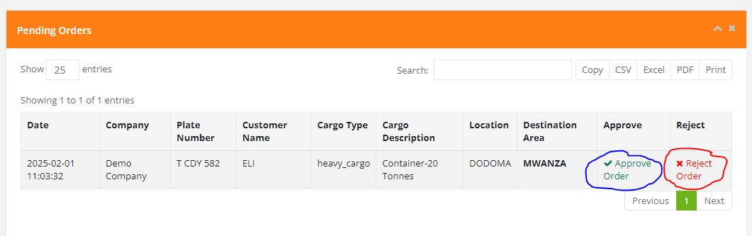

-Mobile application

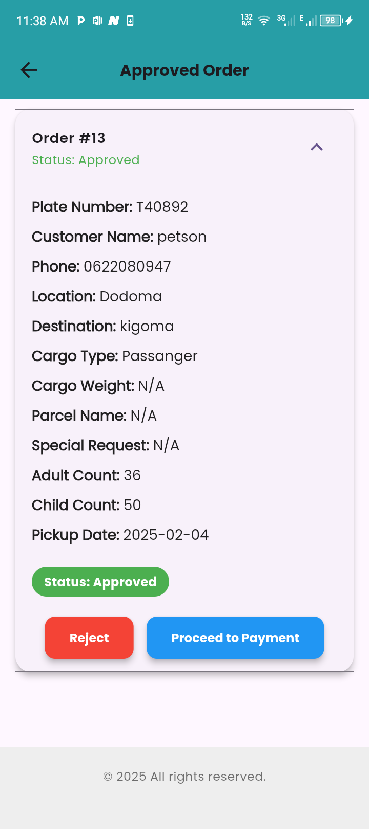

If the order is **approved**, the **vehicle owner** will confirm the order, and communication regarding the **meeting point for loading the cargo** will be established. The **payment terms** will be agreed upon between the customer and the transportation service provider.

After this, it will be the responsibility of the **customer** and the **service provider** to manage the actual transportation process, as this will take place outside the scope of our system.

## 6.7. Vehicles/trucks hosting payment.

This is through the menu All Report > Invoice Report, after which the user will search by date to retrieve all the orders.

Every order placed in the system should be visible to the Chief Admin to ensure payment information is received. The payment criteria for each order will depend on the type of vehicle involved, with these rates being managed by the Chief Admin, who will determine the rates based on needs and discretion.

**Steps for Creating Payment Invoices for Companies:**

* The Admin will have the ability to generate payment invoices for companies to process payments for orders that have not yet been paid for in the transportation system.
* This menu is found by navigating to **All Orders>Invoice.**
* This will allow companies to pay for orders that have been shipped but not yet paid for.

**Payment Information:**

* Once a payment is made, the Admin will have the ability to update the records for orders that have been paid.
* The Chief Admin will have complete visibility over both paid and unpaid orders, ensuring proper payment management.

This process ensures that the system manages payments accurately and as required.

Through the menu **All Reports > Trucks Report**, this menu displays all the orders that have been paid and forwarded to the system owner.

There are two menus in the system that serve similar purposes, but are categorized differently:

### 6.7.1. Orders

These are orders related specifically to the every company admin, and they are divided into three categories:

6.7.1.1 **Pending Orders**  
These are orders that customers have placed to specific Transportation company but have not yet been processed.

6.7.1.2 **Approved Orders**  
These are orders that have been approved by specific Transportation Company

6.7.1.3 **Rejected Orders**  
These are orders that have been rejected by specific Transportation Company

### 6.7.2. All Orders

These are orders placed by different customers with various transportation companies. This menu is also divided into three categories:

6.7.2.1 **Pending Orders**  
These are orders that customers have placed with different transportation companies, but the orders are still pending.

6.7.2.2 **Approved Orders**  
These are orders that have been approved by different transportation companies.

6.7.2.3 **Rejected Orders**  
These are orders that have been rejected by different transportation companies.

6.7.2.4 **Invoice**  
This is where the Super Admin can create invoices for other transportation companies. The Super Admin can search for a specific company name and set a date range, and the system will generate invoices based on the orders made during that period.

Navigate **All Orders > Invoice**

**-web system**

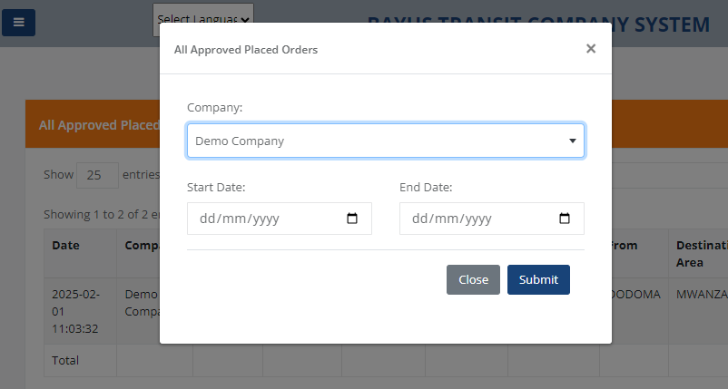

-Mobile application

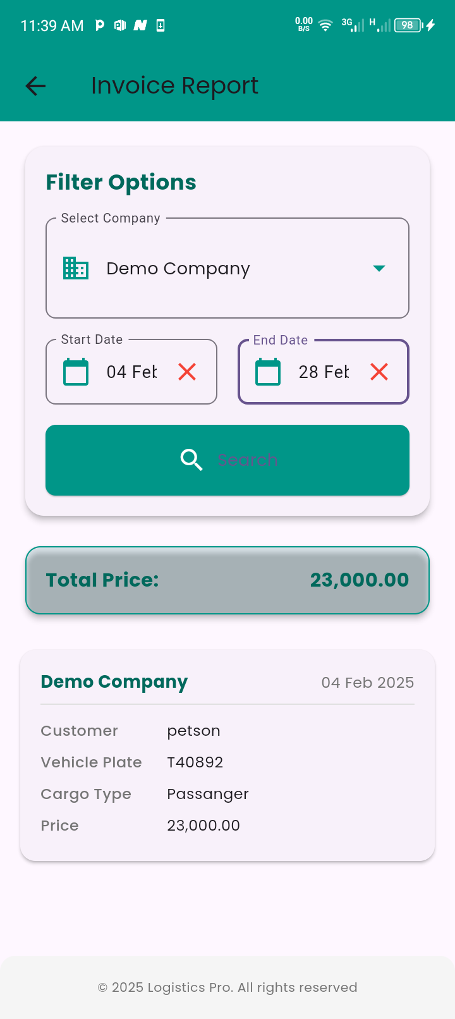

### 6.7.3. Summary:

In short, the **All Orders** menu is intended for the Super Admin, while the **Orders** menu is meant for other transportation companies to monitor the status of their orders, whether they are pending, approved, or rejected. The Super Admin is responsible for managing invoices and generating them based on the orders processed within a given timeframe.

## 6.8. Permissions

This menu manages the access levels for system users. It helps assign specific access rights based on the roles and responsibilities of users within the system.

When navigating to the **Permissions** menu, you will see two submenus:

1. **Permission Info**  
   This section is for registering permissions. Here, the system administrator can define and manage the different permissions that can be assigned to users.
2. **Assign Permission**  
   This menu allows the system administrator to select a user and either grant or revoke their access. The administrator can choose the specific permission they wish to assign or remove and then click the button to apply the changes.

The system user can change their password by navigating to the **Change Password** menu. They will be required to enter their current password, set a new password, and then click the button to change the password.

# Contact and Support

**Contact Information**

Office Location: CENTRE-VILLE, BUJUMBURA, BURUNDI  
Phone: +257 79 97 25 78, +255 745 940 124  
Email: info@bayustransit.com

**Contact Form**

1. Go to "Contact".  
   2. Fill in name, email, subject, and message. 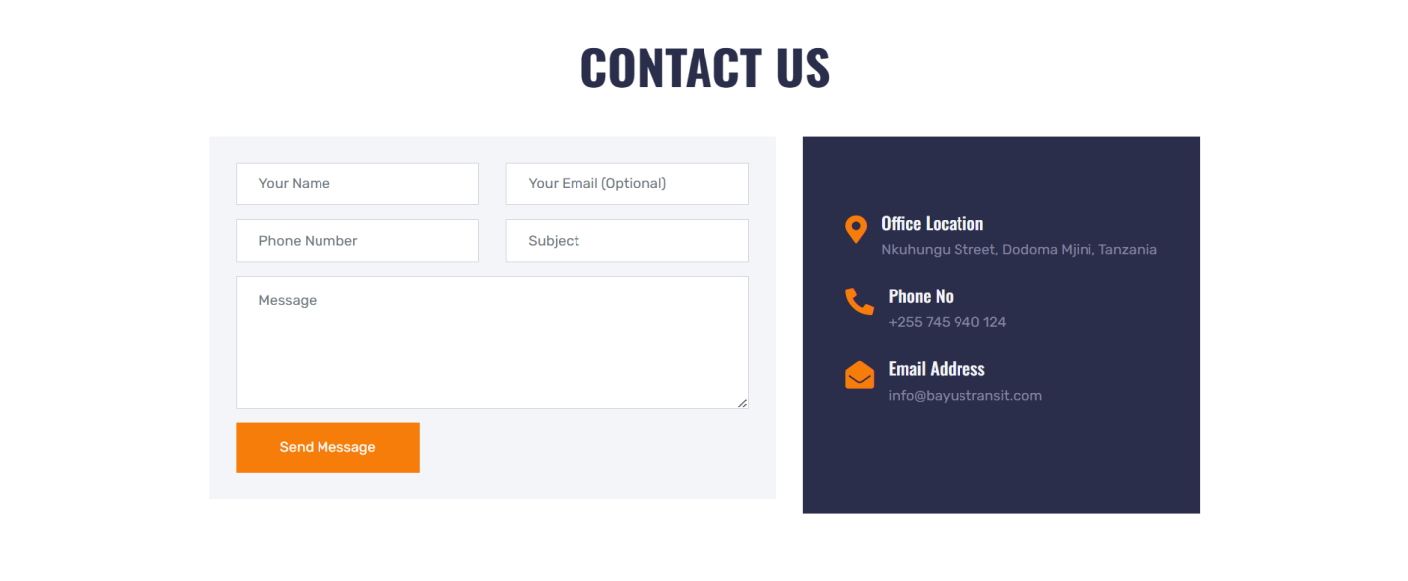  
   3. Submit the form.